PRACTICAL – 7
BVA & EQUIVALENCE PARTITIONING

Module Name: Registration and Login Authentication Module
Test Case ID: P7-BVA-EP
Tester Name: Janvi Patel
Test Case Description: Validation testing using Equivalence Partitioning and Boundary Value Analysis
Prerequisites: Authentication page should be accessible in browser
Environment Information: Windows 11, Google Chrome, QA/Test Environment

Test Scenarios
Scenario EP01
Scenario ID: EP01
Scenario:
Equivalence Partitioning - Username Invalid
Test Steps:
1. Open registration page.
2. Enter username.
3. Enter valid email, password and age.
4. Click Register.
Test Input:
Username: ab
Email: janvi@gmail.com
Password: abc12345
Age: 20
Expected Result:
System should reject username with fewer than 3 characters.
Actual Result:
Invalid Username: Must contain 3-15 characters.
Status:
PASS
Comments:
Invalid username partition tested.
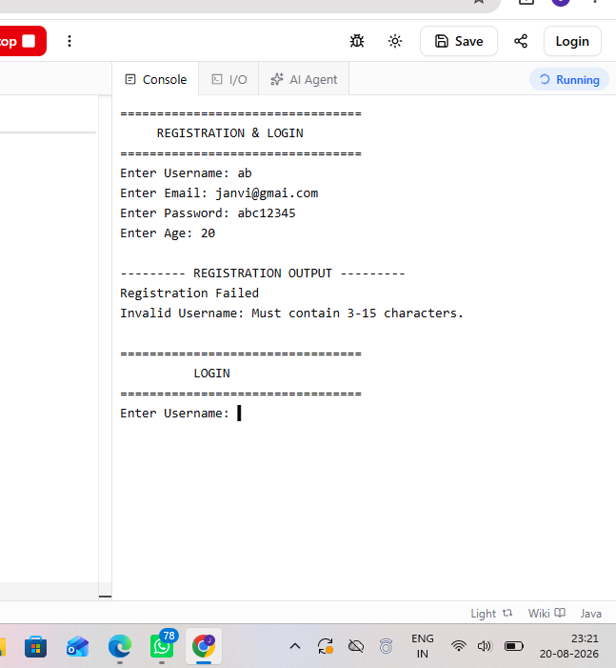

Scenario EP02
Scenario ID: EP02
Scenario:
Equivalence Partitioning - Username Valid
Test Steps:
1. Open registration page.
2. Enter valid username and remaining valid details.
3. Click Register.
Test Input:
Username: janvi
Email: janvi@gmail.com
Password: abc12345
Age: 20
Expected Result:
Registration should be accepted.
Actual Result:
Registration Successful!
Status:
PASS
Comments:
Valid username partition tested.
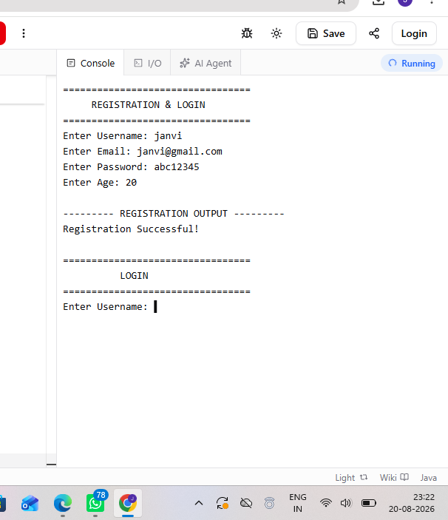
Scenario EP03
Scenario ID: EP03
Scenario:
Equivalence Partitioning - Username Invalid
Test Steps:
1. Open registration page.
2. Enter username longer than 15 characters.
3. Enter valid remaining details.
4. Click Register.
Test Input:
Username: abcdefghijklmnop
Email: janvi@gmail.com
Password: abc12345
Age: 20
Expected Result:
System should reject username longer than 15 characters.
Actual Result:
Invalid Username: Must contain 3-15 characters.
Status:
PASS
Comments:
Invalid upper partition tested.
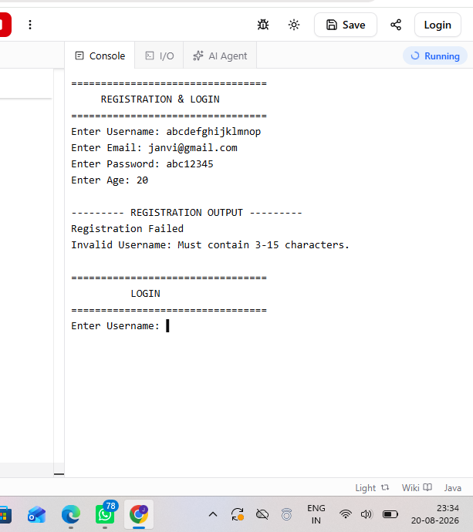
Scenario EP04
Scenario ID: EP04
Scenario:
Equivalence Partitioning - Email Valid
Test Steps:
1. Open registration page.
2. Enter valid registration details.
3. Click Register.
Test Input:
Username: janvi
Email: janvi@gmail.com
Password: abc12345
Age: 20
Expected Result:
Valid email format should be accepted.
Actual Result:
Registration Successful!
Status:
PASS
Comments:
Valid email partition tested.
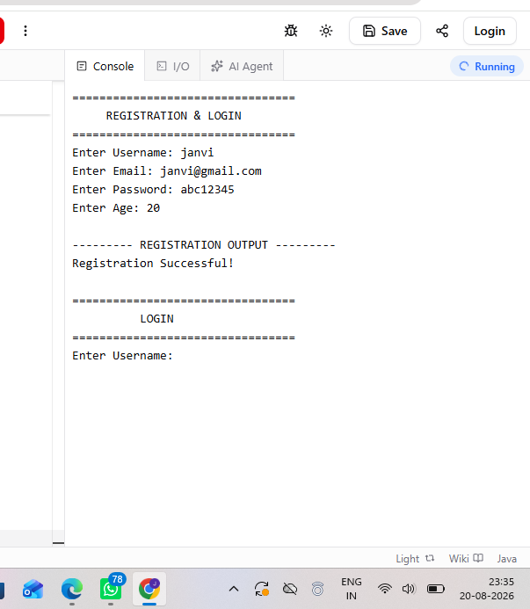
Scenario EP05
Scenario ID: EP05
Scenario:
Equivalence Partitioning - Email Invalid
Test Steps:
1. Open registration page.
2. Enter invalid email format.
3. Enter valid remaining details.
4. Click Register.
Test Input:
Username: janvi
Email: janvigmail.com
Password: abc12345
Age: 20
Expected Result:
System should reject invalid email format.
Actual Result:
Invalid Email Address.
Status:
PASS
Comments:
Invalid email partition tested.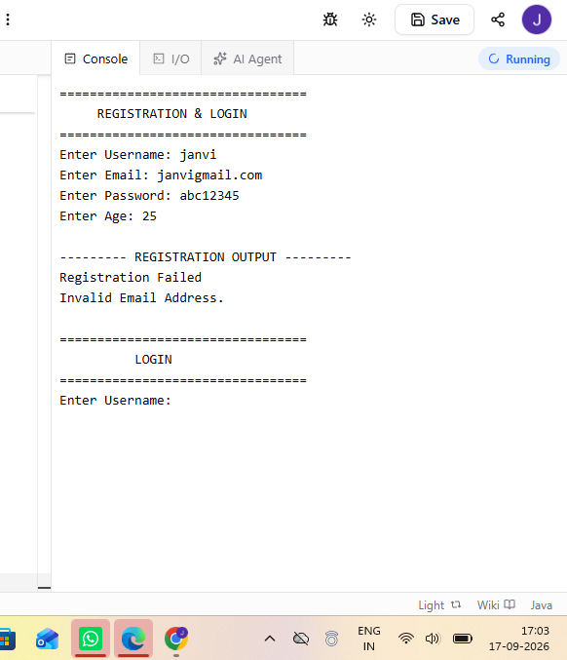
Scenario EP06
Scenario ID: EP06
Scenario:
Equivalence Partitioning - Password Invalid
Test Steps:
1. Open registration page.
2. Enter password shorter than 8 characters.
3. Enter valid remaining details.
4. Click Register.
Test Input:
Username: janvi
Email: janvi@gmail.com
Password: abc123
Age: 20
Expected Result:
System should reject password shorter than 8 characters.
Actual Result:
Invalid Password: Must contain 8-20 characters.
Status:
PASS
Comments:
Invalid password partition tested.
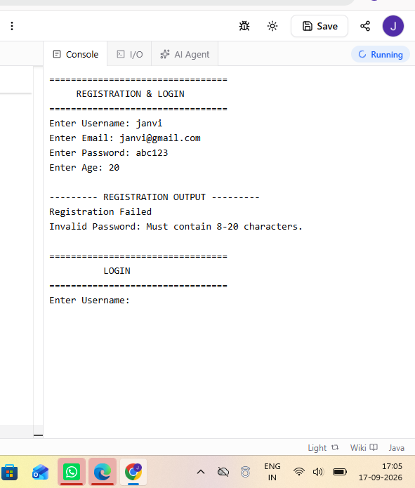

Scenario EP07
Scenario ID: EP07
Scenario:
Equivalence Partitioning - Password Valid
Test Steps:
1. Open registration page.
2. Enter valid password and remaining details.
3. Click Register.
Test Input:
Username: janvi
Email: janvi@gmail.com
Password: abc12345
Age: 20
Expected Result:
System should accept password of 8-20 characters.
Actual Result:
Registration Successful!
Status:
PASS
Comments:
Valid password partition tested.
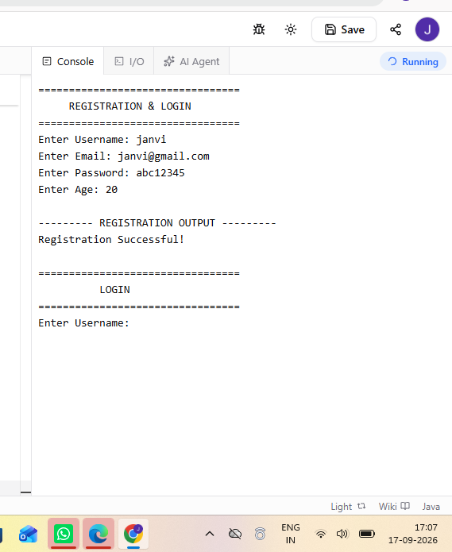

Scenario EP08
Scenario ID: EP08
Scenario:
Equivalence Partitioning - Password Invalid
Test Steps:
1. Open registration page.
2. Enter password longer than 20 characters.
3. Enter valid remaining details.
4. Click Register.
Test Input:
Username: janvi
Email: janvi@gmail.com
Password: abcdefghijklmnopqrstu
Age: 20
Expected Result:
System should reject password longer than 20 characters.
Actual Result:
Invalid Password: Must contain 8-20 characters.
Status:
PASS
Comments:
Invalid upper password partition tested.
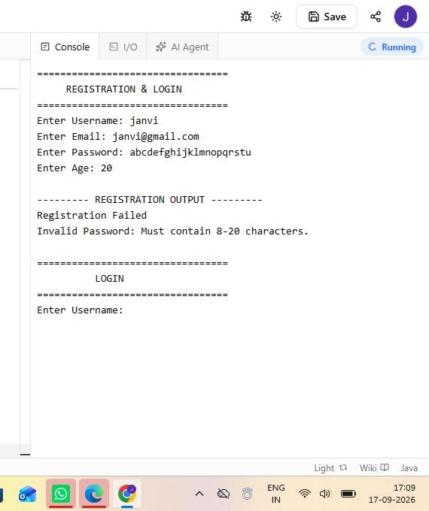

Scenario EP09
Scenario ID: EP09
Scenario:
Equivalence Partitioning - Age Invalid
Test Steps:
1. Open registration page.
2. Enter age below 18.
3. Enter valid remaining details.
4. Click Register.
Test Input:
Username: janvi
Email: janvi@gmail.com
Password: abc12345
Age: 17
Expected Result:
System should reject age below 18.
Actual Result:
Invalid Age: Age must be between 18 and 60.
Status:
PASS
Comments:
Invalid lower age partition tested.
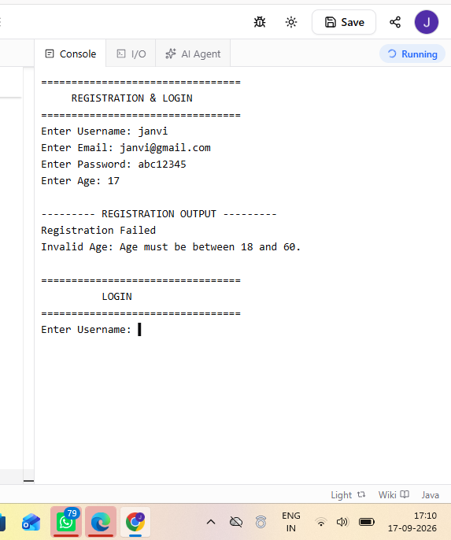
Scenario EP10
Scenario ID: EP10
Scenario:
Equivalence Partitioning - Age Valid
Test Steps:
1. Open registration page.
2. Enter age between 18 and 60.
3. Enter valid remaining details.
4. Click Register.
Test Input:
Username: janvi
Email: janvi@gmail.com
Password: abc12345
Age: 25
Expected Result:
System should accept valid age.
Actual Result:
Registration Successful!
Status:
PASS
Comments:
Valid age partition tested.
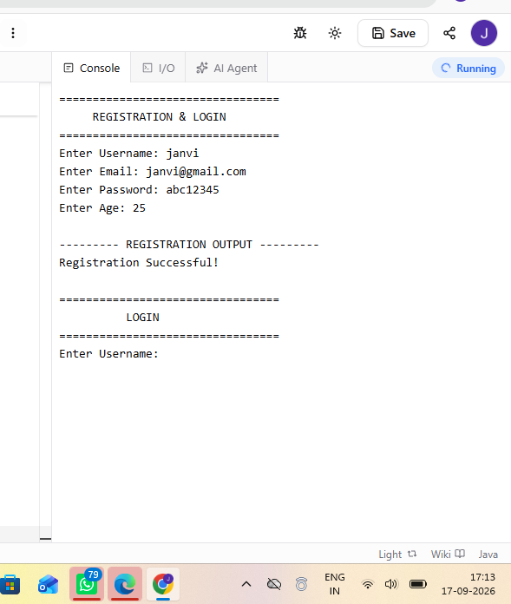
Scenario EP11
Scenario ID: EP11
Scenario:
Equivalence Partitioning - Age Invalid
Test Steps:
1. Open registration page.
2. Enter age above 60.
3. Enter valid remaining details.
4. Click Register.
Test Input:
Username: janvi
Email: janvi@gmail.com
Password: abc12345
Age: 61
Expected Result:
System should reject age above 60.
Actual Result:
Invalid Age: Age must be between 18 and 60.
Status:
PASS
Comments:
Invalid upper age partition tested.
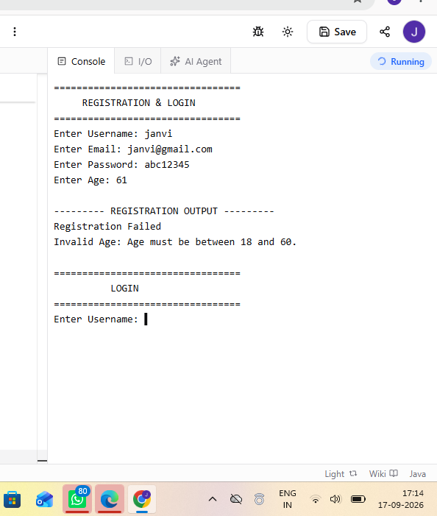

Scenario BVA01
Scenario ID: BVA01
Scenario:
BVA - Age Min-1
Test Steps:
1. Open registration page.
2. Enter age 17.
3. Enter valid remaining details.
4. Click Register.
Test Input:
Age: 17
Expected Result:
Age 17 should be rejected.
Actual Result:
Invalid Age: Age must be between 18 and 60.
Status:
PASS
Comments:
Minimum boundary - 1.

Scenario BVA02
Scenario ID: BVA02
Scenario:
BVA - Age Min
Test Steps:
1. Open registration page.
2. Enter age 18.
3. Enter valid remaining details.
4. Click Register.
Test Input:
Age: 18
Expected Result:
Age 18 should be accepted.
Actual Result:
Registration Successful!
Status:
PASS
Comments:
Minimum boundary.
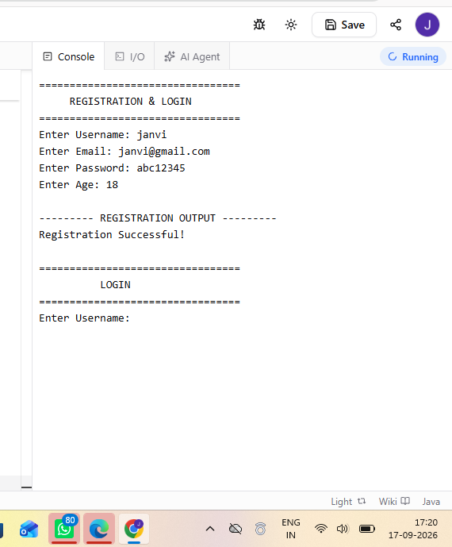

Scenario BVA03
Scenario ID: BVA03
Scenario:
BVA - Age Min+1
Test Steps:
1. Open registration page.
2. Enter age 19.
3. Enter valid remaining details.
4. Click Register.
Test Input:
Age: 19
Expected Result:
Age 19 should be accepted.
Actual Result:
Registration Successful!
Status:
PASS
Comments:
Minimum boundary + 1.
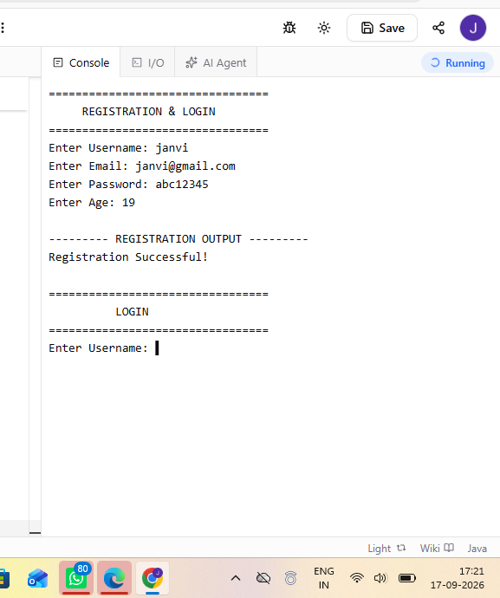
Scenario BVA04
Scenario ID: BVA04
Scenario:
BVA - Age Max-1
Test Steps:
1. Open registration page.
2. Enter age 59.
3. Enter valid remaining details.
4. Click Register.
Test Input:
Age: 59
Expected Result:
Age 59 should be accepted.
Actual Result:
Registration Successful!
Status:
PASS
Comments:
Maximum boundary - 1.
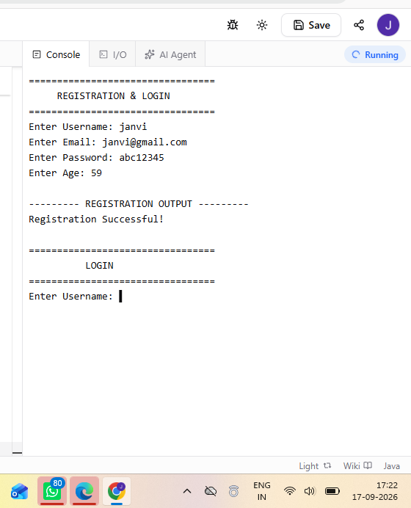
Scenario BVA05
Scenario ID: BVA05
Scenario:
BVA - Age Max
Test Steps:
1. Open registration page.
2. Enter age 60.
3. Enter valid remaining details.
4. Click Register.
Test Input:
Age: 60
Expected Result:
Age 60 should be accepted.
Actual Result:
Registration Successful!
Status:
PASS
Comments:
Maximum boundary.
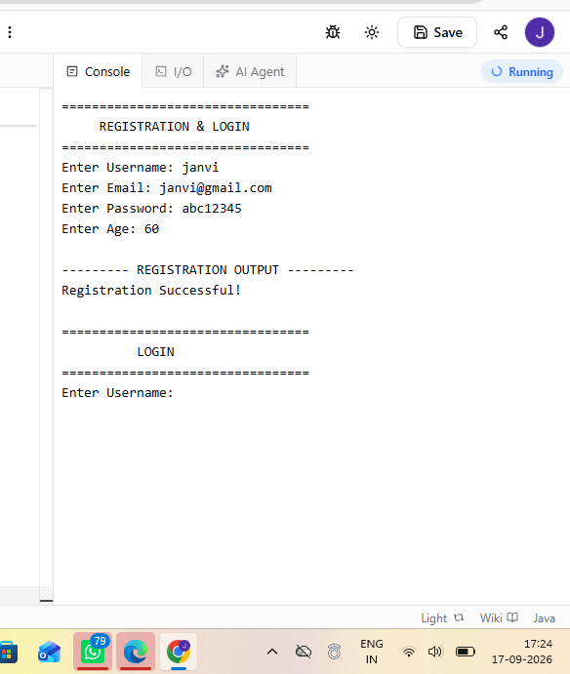
Scenario BVA06
Scenario ID: BVA06
Scenario:
BVA - Age Max+1
Test Steps:
1. Open registration page.
2. Enter age 61.
3. Enter valid remaining details.
4. Click Register.
Test Input:
Age: 61
Expected Result:
Age 61 should be rejected.
Actual Result:
Invalid Age: Age must be between 18 and 60.
Status:
PASS
Comments:
Maximum boundary + 1.
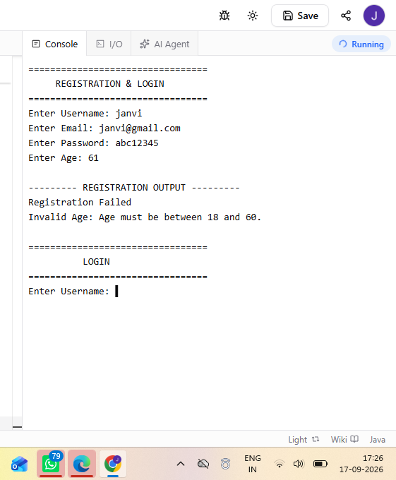
Scenario BVA07
Scenario ID: BVA07
Scenario:
BVA - Username Min-1
Test Steps:
1. Open registration page.
2. Enter a 2-character username.
3. Enter valid remaining details.
4. Click Register.
Test Input:
Username length: 2
Expected Result:
Username with length 2 should be rejected.
Actual Result:
Invalid Username: Must contain 3-15 characters.
Status:
PASS
Comments:
Minimum length - 1.
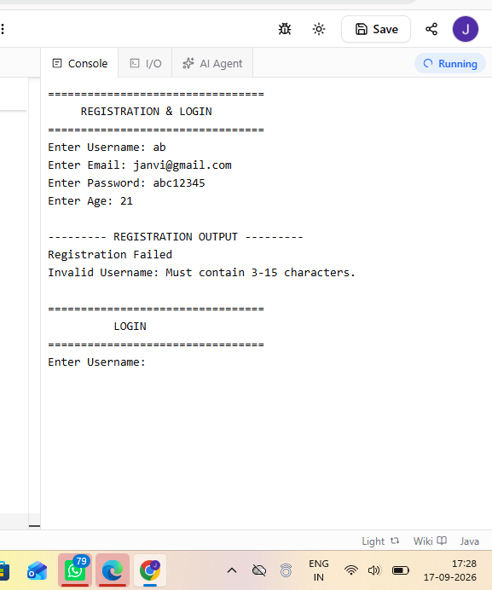
Scenario BVA08
Scenario ID: BVA08
Scenario:
BVA - Username Min
Test Steps:
1. Open registration page.
2. Enter a 3-character username.
3. Enter valid remaining details.
4. Click Register.
Test Input:
Username length: 3
Expected Result:
Username with length 3 should be accepted.
Actual Result:
Registration Successful!
Status:
PASS
Comments:
Minimum length.
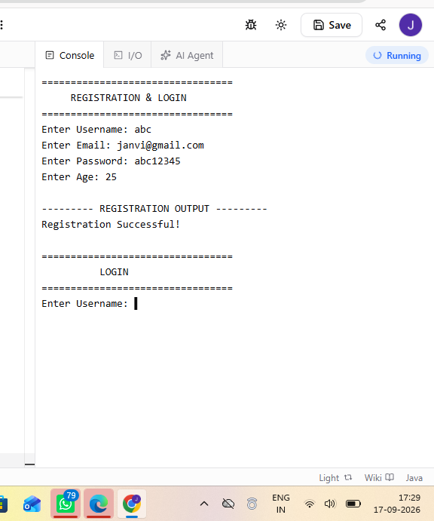
Scenario BVA09
Scenario ID: BVA09
Scenario:
BVA - Username Min+1
Test Steps:
1. Open registration page.
2. Enter a 4-character username.
3. Enter valid remaining details.
4. Click Register.
Test Input:
Username length: 4
Expected Result:
Username with length 4 should be accepted.
Actual Result:
Registration Successful!
Status:
PASS
Comments:
Minimum length + 1.
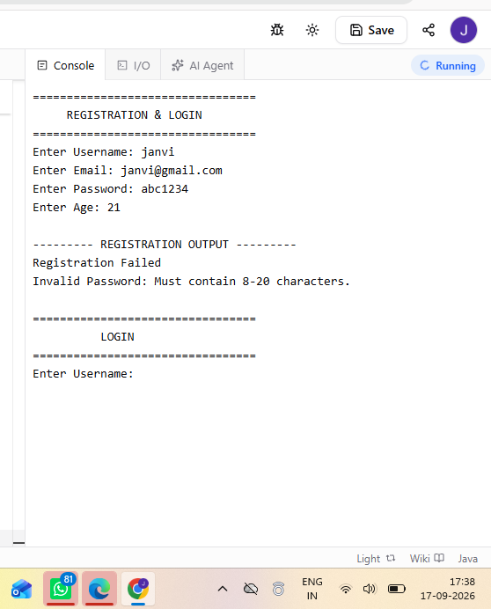
Scenario BVA10
Scenario ID: BVA10
Scenario:
BVA - Username Max-1
Test Steps:
1. Open registration page.
2. Enter a 14-character username.
3. Enter valid remaining details.
4. Click Register.
Test Input:
Username length: 14
Expected Result:
Username with length 14 should be accepted.
Actual Result:
Registration Successful!
Status:
PASS
Comments:
Maximum length - 1.
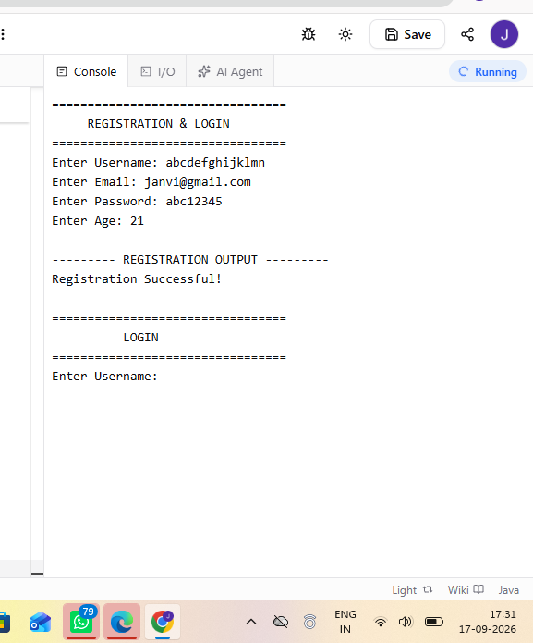
Scenario BVA11
Scenario ID: BVA11
Scenario:
BVA - Username Max
Test Steps:
1. Open registration page.
2. Enter a 15-character username.
3. Enter valid remaining details.
4. Click Register.
Test Input:
Username length: 15
Expected Result:
Username with length 15 should be accepted.
Actual Result:
Registration Successful!
Status:
PASS
Comments:
Maximum length.
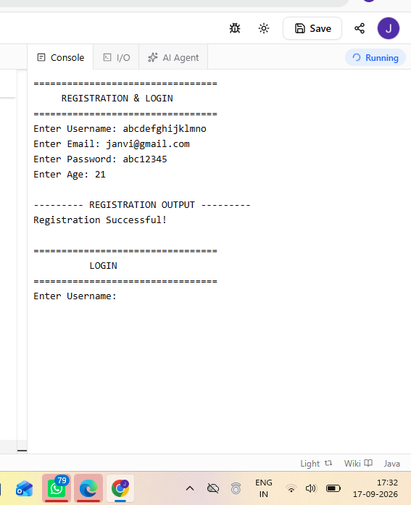
Scenario BVA12
Scenario ID: BVA12
Scenario:
BVA - Username Max+1
Test Steps:
1. Open registration page.
2. Enter a 16-character username.
3. Enter valid remaining details.
4. Click Register.
Test Input:
Username length: 16
Expected Result:
Username with length 16 should be rejected.
Actual Result:
Invalid Username: Must contain 3-15 characters.
Status:
PASS
Comments:
Maximum length + 1.
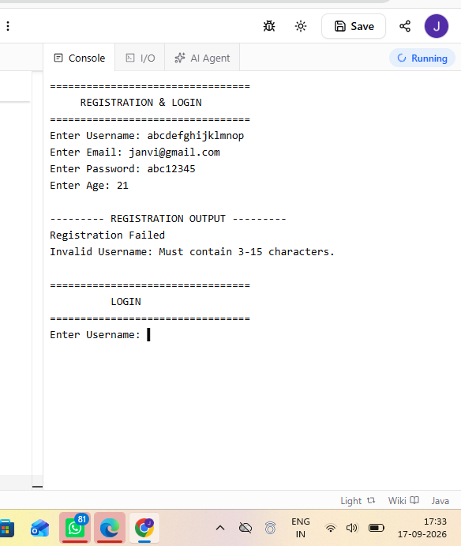
Scenario BVA13
Scenario ID: BVA13
Scenario:
BVA - Password Min-1
Test Steps:
1. Open registration page.
2. Enter a 7-character password.
3. Enter valid remaining details.
4. Click Register.
Test Input:
Password length: 7
Expected Result:
Password with length 7 should be rejected.
Actual Result:
Invalid Password: Must contain 8-20 characters.
Status:
PASS
Comments:
Minimum length - 1.
Scenario BVA14
Scenario ID: BVA14
Scenario:
BVA - Password Min
Test Steps:
1. Open registration page.
2. Enter an 8-character password.
3. Enter valid remaining details.
4. Click Register.
Test Input:
Password length: 8
Expected Result:
Password with length 8 should be accepted.
Actual Result:
Registration Successful!
Status:
PASS
Comments:
Minimum length.
Scenario BVA15
Scenario ID: BVA15
Scenario:
BVA - Password Min+1
Test Steps:
1. Open registration page.
2. Enter a 9-character password.
3. Enter valid remaining details.
4. Click Register.
Test Input:
Password length: 9
Expected Result:
Password with length 9 should be accepted.
Actual Result:
Registration Successful!
Status:
PASS
Comments:
Minimum length + 1.
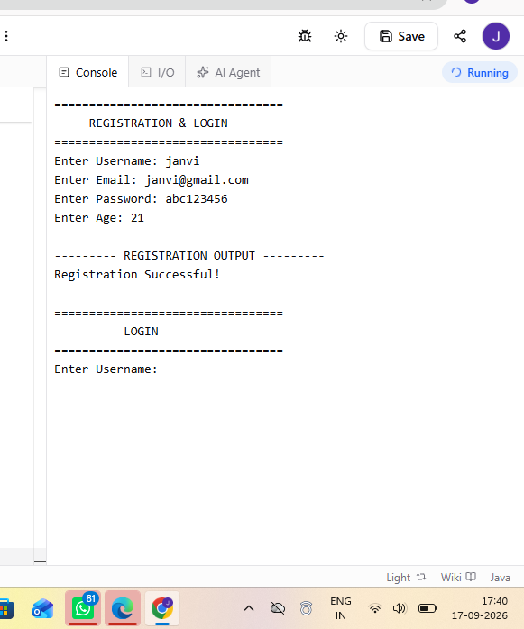
Scenario BVA16
Scenario ID: BVA16
Scenario:
BVA - Password Max-1
Test Steps:
1. Open registration page.
2. Enter a 19-character password.
3. Enter valid remaining details.
4. Click Register.
Test Input:
Password length: 19
Expected Result:
Password with length 19 should be accepted.
Actual Result:
Registration Successful!
Status:
PASS
Comments:
Maximum length - 1.
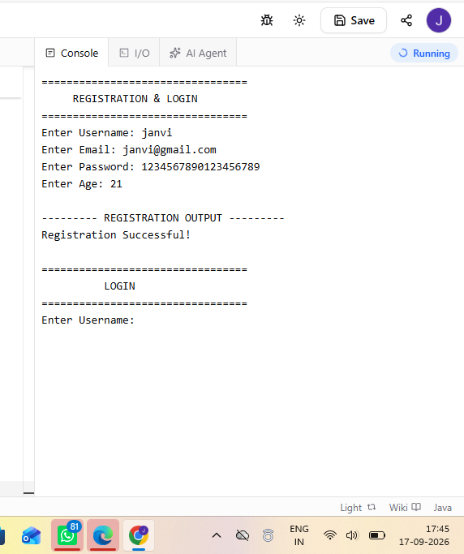
Scenario BVA17
Scenario ID: BVA17
Scenario:
BVA - Password Max
Test Steps:
1. Open registration page.
2. Enter a 20-character password.
3. Enter valid remaining details.
4. Click Register.
Test Input:
Password length: 20
Expected Result:
Password with length 20 should be accepted.
Actual Result:
Registration Successful!
Status:
PASS
Comments:
Maximum length.
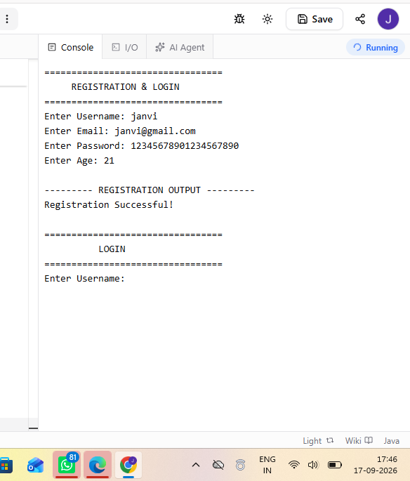
Scenario BVA18
Scenario ID: BVA18
Scenario:
BVA - Password Max+1
Test Steps:
1. Open registration page.
2. Enter a 21-character password.
3. Enter valid remaining details.
4. Click Register.
Test Input:
Password length: 21
Expected Result:
Password with length 21 should be rejected.
Actual Result:
Invalid Password: Must contain 8-20 characters.
Status:
PASS
Comments:
Maximum length + 1.
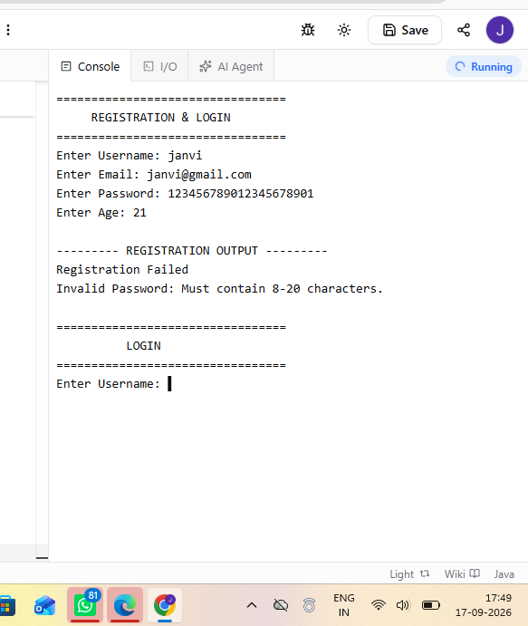
Scenario AUTH01
Scenario ID: AUTH01
Scenario:
Authentication - Valid Login
Test Steps:
1. Register a valid user.
2. Open login form.
3. Enter registered username and password.
4. Click Login.
Test Input:
Username: janvi
Password: abc12345
Expected Result:
User should be logged in successfully.
Actual Result:
Login Successful!
Status:
PASS
Comments:
Normal login functionality works.
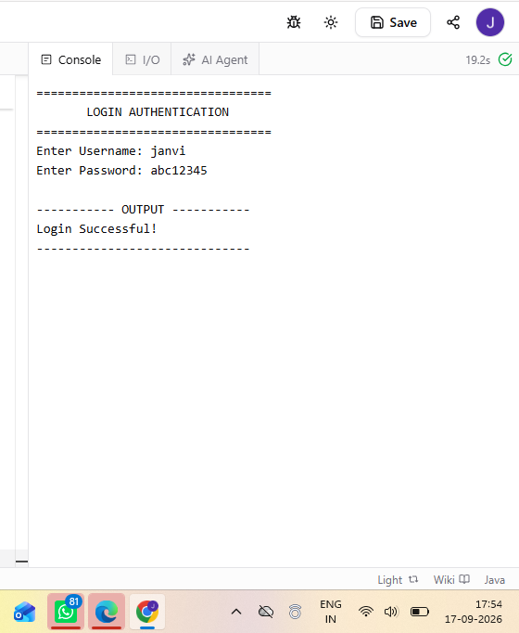
Scenario AUTH02
Scenario ID: AUTH02
Scenario:
Authentication - Invalid Password
Test Steps:
1. Register a valid user.
2. Open login form.
3. Enter correct username and wrong password.
4. Click Login.
Test Input:
Username: janvi
Password: wrong123
Expected Result:
System should reject invalid credentials.
Actual Result:
Invalid Username or Password.
Status:
PASS
Comments:
Invalid credential handling works.
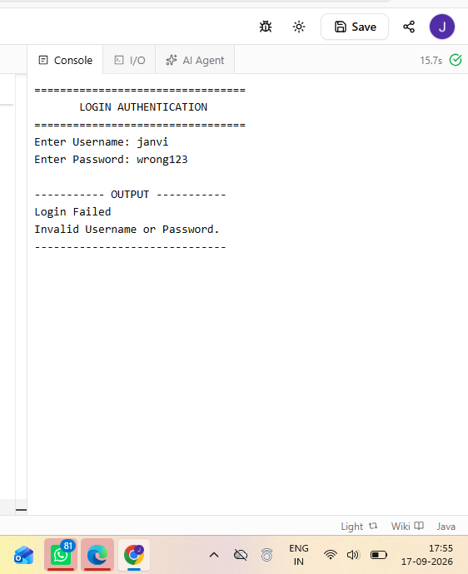
Scenario AUTH03
Scenario ID: AUTH03
Scenario:
Authentication - Blank Password
Test Steps:
1. Register a valid user.
2. Open login form.
3. Enter username.
4. Leave password blank.
5. Click Login.
Test Input:
Username: janvi
Password: Blank
Expected Result:
System should display a password-required validation message.
Actual Result:
Invalid Username or Password.
Status:
FAIL
Comments:
BUG-001: Specific empty-password validation message is missing. Severity: Medium, Priority: High.
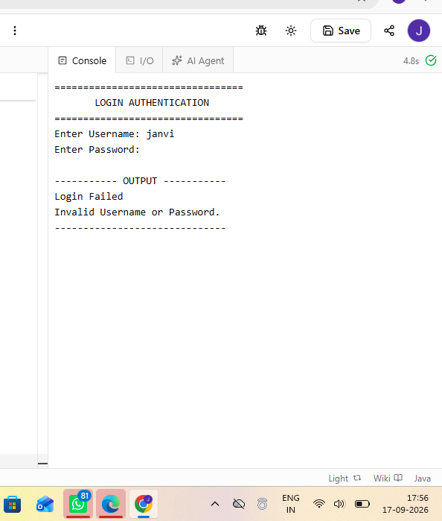
Scenario AUTH04
Scenario ID: AUTH04
Scenario:
Authentication - Blank Username
Test Steps:
1. Open login form.
2. Leave username blank.
3. Enter password.
4. Click Login.
Test Input:
Username: Blank
Password: abc12345
Expected Result:
System should reject login and display username validation or authentication error.
Actual Result:
Invalid Username or Password.
Status:
PASS
Comments:
Blank username is rejected.
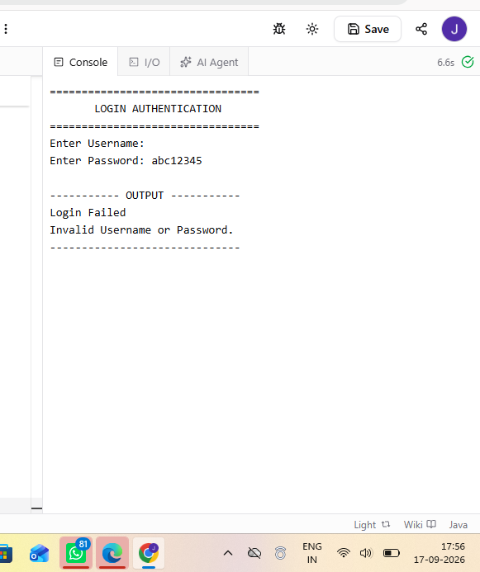
BUG-001 – Specific Empty Password Validation Missing
Bug ID: BUG-001

Defect Title: Specific Empty Password Validation Message Missing

Module Name: Login Authentication

Feature Affected: Password Validation / User Authentication

Defect Type: Functional

Severity: Medium

Priority: High

Environment: Windows 11, Google Chrome, QA/Test Environment

Reported By: Janvi Patel

Defect Description:
When the password field is left blank during login, the system displays a generic authentication error instead of the expected password-required validation message.

Steps to Reproduce:
1. Register a valid user.
2. Open the login form.
3. Enter username: janvi.
4. Leave password field blank.
5. Click Login.
Expected Result:
System should display a password-required validation message.
Actual Result:
Invalid Username or Password.
Bug Status: Open

Resolution: Pending

Retest Status: Not Retested

Remarks: Specific empty-password validation message is missing.

Test Execution Summary
Parameter | Result
Total Test Cases | 33
Passed | 32
Failed | 1
Pass Percentage | 96.97%
Overall Status | FAIL – BUG-001 identified

Observation
- Equivalence Partitioning was applied to username, email, password and age input classes.
- Boundary Value Analysis was applied to age, username length and password length boundaries.
- The defined test scenarios were executed and the results were documented.
- BUG-001 was identified in the blank-password authentication scenario.
- The defect was classified as Medium severity and High priority.
- Screenshots should be attached as evidence for the reproduced defect.
Output:
BVA and Equivalence Partitioning test scenarios were executed successfully, and the identified authentication defect was documented with reproduction details, severity, priority and status.
Conclusion:
The practical successfully demonstrates the application of Boundary Value Analysis and Equivalence Partitioning for validation testing of registration and login authentication inputs. The identified defect was documented for fixing and retesting.

